MODBUS Gateway User's Manual
ADM-5850G
MODBUS protocol is one of the most widely used general protocols in electronic industrial equipment, and has become a general industrial standard. Through this protocol, a variety of MODBUS devices (such as PLC, DCS, HMI, various instruments, etc.) can communicate with each other via a network or a serial link. Nevertheless, the MODBUS protocol used on the serial port and Ethernet is different, so a gateway is needed to complete the communication transformation between the two protocols. ADM-5850G is a product dedicated to connecting MODBUS TCP devices and MODBUS RTU/ASCII devices.
ADM-5850G is a multifunctional serial MODBUS gateway, which integrates MODBUS TCP, MODBUS RTU and MODBUS ASCII protocol, and the device can be configured flexibly through serial port software RS232, RS422 or RS485 mode, the user can easily use it to seamlessly integrate MODBUS Ethernet devices with MODBUS serial devices.
ADM-5850G The features of the product：
1, 32 bit ARM Cortex-m3 CPU
2, 10/100M Ethernet interface (RJ45 interface)
3, serial port support RS232, RS422, RS485 three kinds of interface optional
Users support the baud rate arbitrarily to set 300~230400bps, the maximum rate of RS-232 mode is 115Kbps, RS485 or RS422 mode is at the highest rate of 230400bps.The serial data bit, the stop bit and the check bit can be set.
4, The support agreement includes: ETHERNET、ARP、IP、ICMP、IGMP、UDP、TCP、DHCP，DNS、MODBUS TCP、MODBUS RTU、MODBUS ASCII；
5, Provide four ways of work:
RTU_ Master--TCP_ Slaver
TCP_ Master--RTU_ Slaver
ASCII_ Master--TCP_ Slaver
TCP_ Master--ASCII_ Slaver
6, Maximum support for 32 Mod bus TCP master connections
7, The automatic adaption of time - time character
8, provide ID mapping function to realize the management of host ID.
9, the work port, the target IP and the port can be set.
10, can be configured using Web Server, Telnet, MG Configuration tool
11, industrial design, can be stable for a long time in bad environment.
12, input voltage: DC9~48V, maximum working current: 200mA
13, working temperature: -20~75 degrees C;
14, storage temperature: - 40~85 degrees C;
15, 35mm DIN guide rail installation method;
16, size: 103x72x27 (mm), long x wide x high (millimeter).

Typical applications:
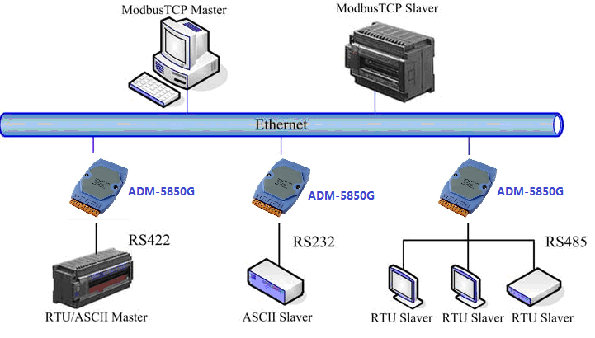

ADM-5850G Configuration instructions
There are three types of configuration in ADM-5850G, which are Telnet remote configuration, Web Server configuration, and MG Configuration PC tool.
Web Server configuration
1、Open the IE browser
Enter the IP address of the ADM-5850G MODBUS gateway server in the address bar (default: 192.168.10.245)
2、Basic Setting
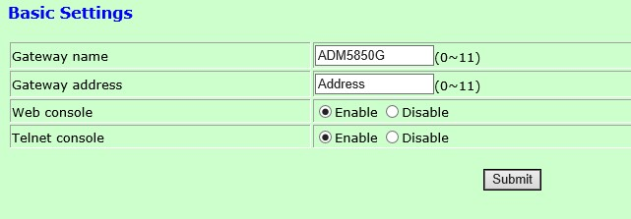
Gateway Name: give the device a name (not more than 11 characters).
Gateway address: the location of the device
Web console: Enable enables Web configuration, and Disable closes the Web configuration.
Telnet console: Enable enables Telnet configuration, and Disable closes the Telnet configuration.
3、Network parameter configuration
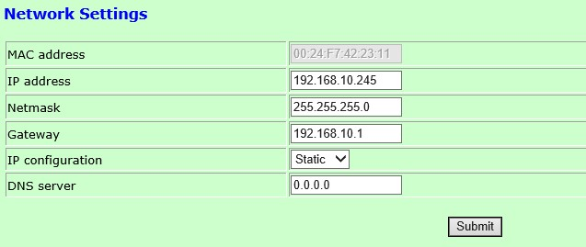
MAC address: ADM-5850G device can not be changed.
IP address: ADM-5850G device in the network.
Net mask: subnet mask.
Gateway: gateway address.
IP configuration: DHCP: dynamic IP, Static: static IP address.
DNS server: when the target IP is a domain name, DNS server is the IP address of the domain name resolution server.
4、serial port parameters
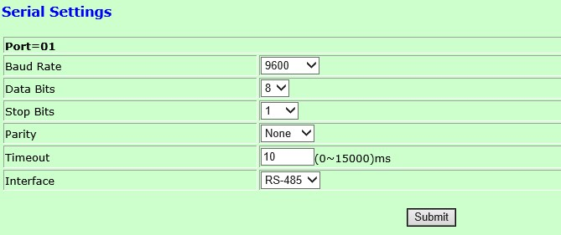
Baud Rate: baud rate, select 300~230400.
Data Bits: the data bit length of the serial port, the 6,7,8 bit can be selected.
Stop Bits: the stop bit length of the serial port, and the 1,1.5,2 bit can be selected.
Parity: the default is no parity.
Timeout: When the MODBUS serial device is MODBUS RTU, it determines every packet by determining the time interval between characters. If the character time is not set, it will cause the check error. The value is (0~15000) milliseconds, when set to 0, it is automatically adapted to the time state of the character timeout.
Interface: the interface type of the serial port, the serial port of ADM-5850G can be selected as the three formats of RS232, RS485 and RS422.
RS-232 signals: TXD, RXD, RTS, CTS, GND
RS-422 signals: T+, T-, R+, R-
RS-485 signal: D+, D-
Direction control: RS-485 uses data flow direction automatic control technology
Load capacity: RS-485/422 terminal support 32 node polling
Transmission distance: the RS-485/422 end is 1000 meters, and the RS-232 mouth is 10 meters
Interface protection: 1500W surge protection, 15KV electrostatic protection
Interface form: RS-232 terminal DB-9 head, RS-485/422 terminal
5、Operation mode configuration of MODBUS gateway
ADM-5850G MODBUS Gateway provides 4 ways of working:
(1), TCP_ Master--RTU_ Slaver: the network is the MODBUS TCP master device, and the serial port is MODBUS RTU slave the device.
(2), TCP_ Master--ASCII_ Slaver: the network is the MODBUS TCP master device, and the serial port is MODBUS ASCII slave the device.
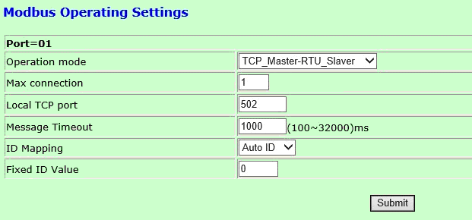
Max connection: It supports up to 32 MODBUS TCP main devices, and users can set them according to the actual application. When users are less than 32 connections, they can be small enough to improve performance. The valid range is 1~32.
Local TCP port: The default port number of the standard MODBUS TCP protocol is 502, and the user can also modify it according to its own application.
Message Timeout: Master device needs a response timeout time when accessing slave device. This time is "message timeout time". The effective setting of this parameter is (100~32000) milliseconds, and the default value of this parameter is 200ms.
ID Mapping: ID mapping function, which can choose automatic ID and fixed ID
AUTO: When the enable is selected, the ID number in the request frame sent by the MODBUS TCP master device does not make any changes to the serial slave device.
Fixed: When selecting enable, change the request ID number sent by the MODBUS TCP main device to the set fixed ID number, then send it to the serial port slave device, and transform the ID number in the response frame returned by the serial slave device.
Fixed ID Value：Fixed ID, when selecting Fixed, the Gateway device uses a fixed ID to access the slave device under the serial port, and the fixed ID number is set to 1~247.
(3),RTU_ Master--TCP_ Slaver:
the network is MODBUS TCP Slave the device, the serial port is the MODBUS RTU master device.
(4), ASCII_ Master--TCP_ Slaver:
the network is MODBUS TCP Slave the device , the serial port is
the MODBUS ASCII master device.
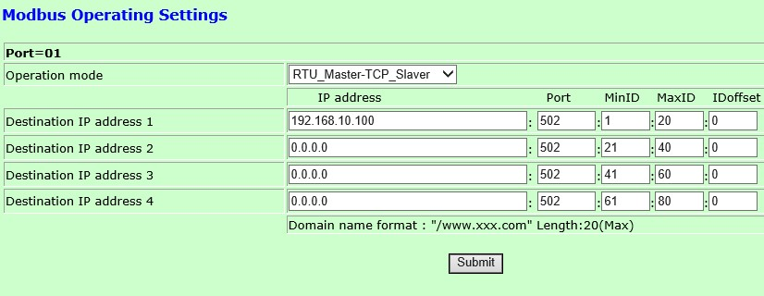
Destination IP address：When the Gateway device works in TCP_ Slaver mode, it can support 4 MODBUS TCP slave devices. The user can connect the corresponding MODBUS TCP slave device by enabling the target host. The target connection is not used. The IP address is modified to 0.0.0.0, otherwise it will cause the Gateway device to continuously send the connection request, which will affect the network and device performance.
When the target host is presented in a domain name fold, a domain name is added to the domain name when the domain name is set. The length of the domain name is not more than 20 characters.
Port：The port number of the target host, the default port number of the standard MODBUS TCP protocol is 502.
ID mapping:
Min ID/Max ID：ID minimum and ID maximum. When the serial MODBUS master device accesses the TCP slave device, Gateway will search through this ID range to see whether the target exists, and find the corresponding target to forward the request of master device. The valid range is 1~247. At the same time, the maximum value of ID can't be less than the minimum value of ID. Otherwise, as the minimum value of ID is processed, the maximum value of ID is smaller or equal than that of setting the corresponding ID minimum value. Gateway device will set ID as the minimum value of ID. Note: the ID range of the enabled target is not repeatable, otherwise the ID part that the rear target is covered can not be retrieved.
ID offset：All the slave devices must have a unique ID number (1~247). The ID number is used to identify the slave address to respond to the request sent by the host device. The device ID number MODBUS is set by the manufacturers, most can modify the ID offset is used to specify each Gateway connection from the MODBUS machine, when the MODBUS host through the serial port (RS232/422/485) access from the machine when the target ID number will be added to the network after the offset of the MODBUS from the machine, in the MODBUS data from the machine Gateway device to ID, minus the offset and then sent to the serial port on the host MODBUS.

